Name: M.VINAY
Roll No: 23BQ1A4951
PBL ID:DB_262790141
Date: 16-07-2026
Topic: Introduction to SQL(Restricting and sorting Data)

1. Display Ename, Sal, Comm from Emp who earn commission, sorted descending by Salary and Comm (using column position).
Ans
Sql :
SELECT ENAME, SAL, COMM
FROM EMP
WHERE COMM IS NOT NULL
ORDER BY 2 DESC, 3 DESC;
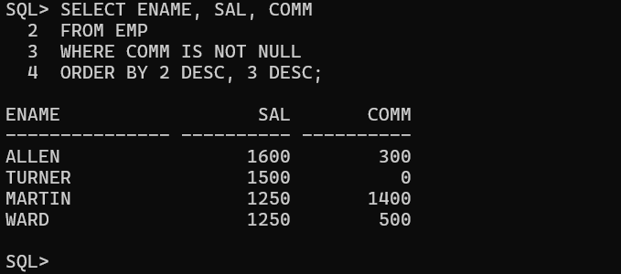

2. Display all unique job codes from EMP table.
Ans to find only unique codes
Sql : SELECT DISTINCT JOB
FROM EMP;
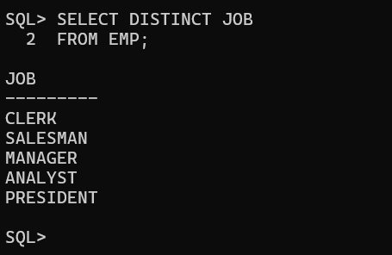
3. Column aliases: Emp #, Employee, Job, Hire Date.
Ans
sql :
SELECT EMPNO AS "Emp #", ENAME AS "Employee", JOB AS "Job", HIREDATE AS "Hire Date" FROM EMP;
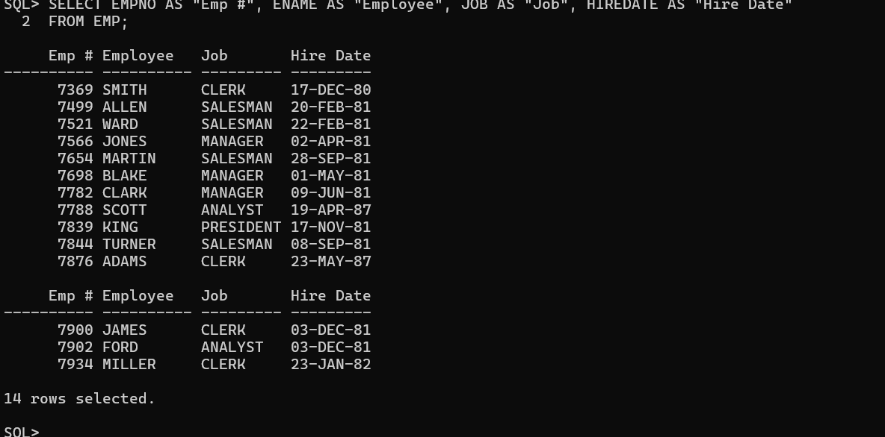
4. Last name concatenated with job ID (comma + space), column alias "Employee and Title".
Ans
sql : SELECT ENAME || ', ' || JOB AS "Employee and Title"
FROM EMP;
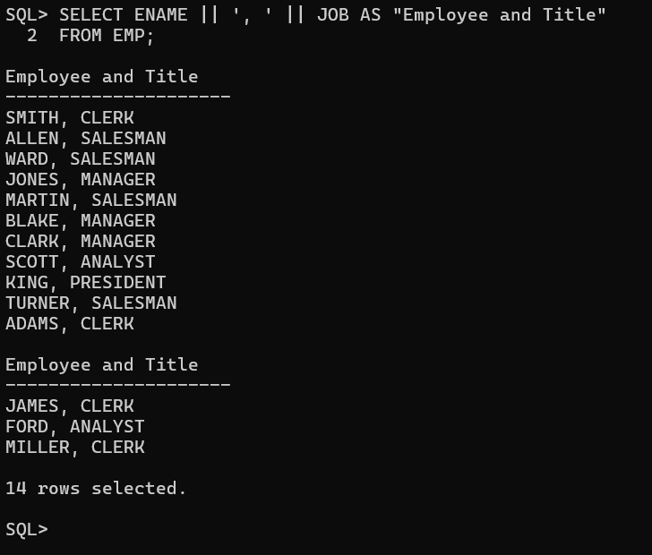

5. Display ENAME, JOB, HIREDATE, MGR separated by commas, column alias THE_OUTPUT.
Sql : SELECT ENAME || ', ' || JOB || ', ' || HIREDATE || ', ' || MGR AS THE_OUTPUT
FROM EMP;
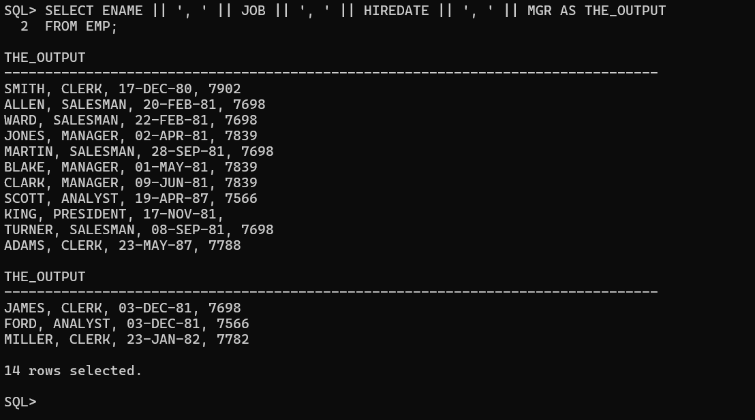

6. Ename, Job, Hiredate for employees named SCOTT or TURNER, ascending order by hiredate.
Ans
sql : SELECT ENAME, JOB, HIREDATE
FROM EMP
WHERE ENAME IN ('SCOTT', 'TURNER')
ORDER BY HIREDATE ASC;
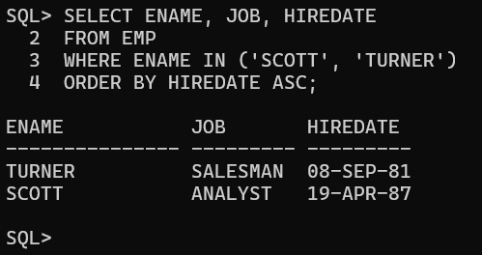

7. Ename and Deptno for employees in dept 20 or 30, ascending alphabetical order by ename.
Sql : SELECT ENAME, DEPTNO
FROM EMP
WHERE DEPTNO IN (20, 30)
ORDER BY ENAME ASC;
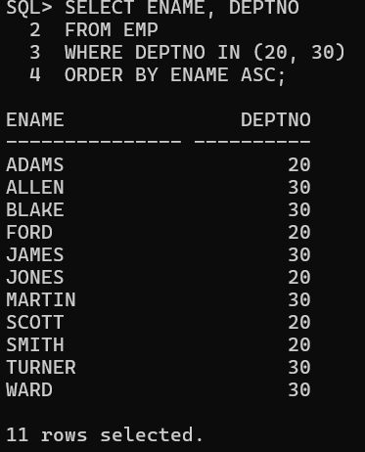
8. Last name and salary for employees earning between 2000 and 3000 in dept 20 or 30, aliases "Employee" and "Monthly Salary".
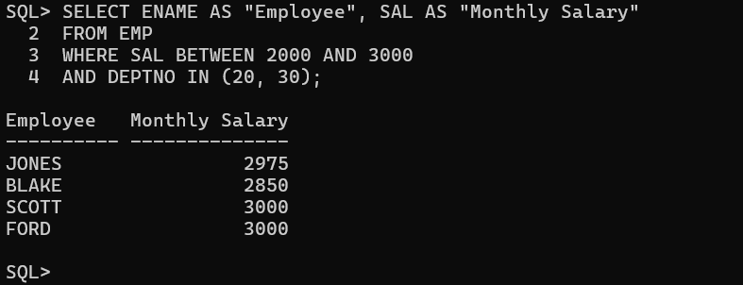

9. Last name and hire date for employees hired in 1981.
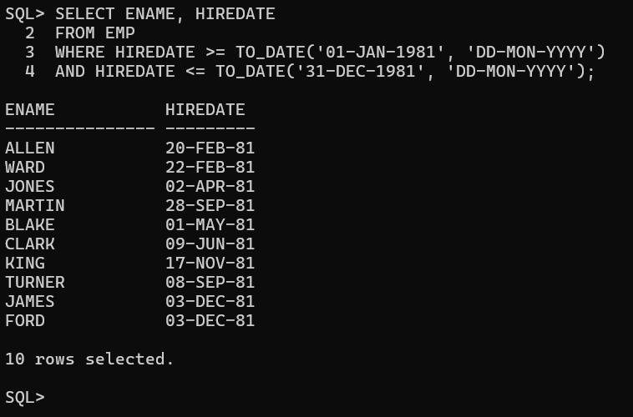
10. Ename, Sal of employees earning more than a user-specified amount, using a prompt.
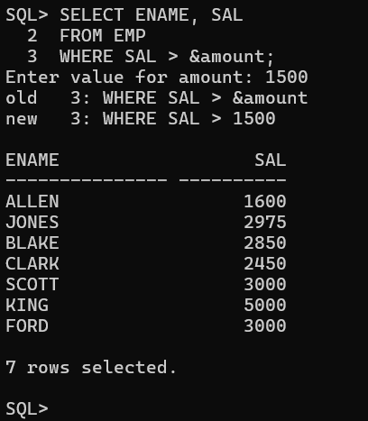
11. Last name and job title of employees who do not have a manager.
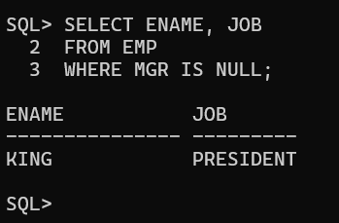
12. Prompt for Manager ID, generate EMPNO, ENAME, SAL, DEPTNO; ability to sort on a selected column.
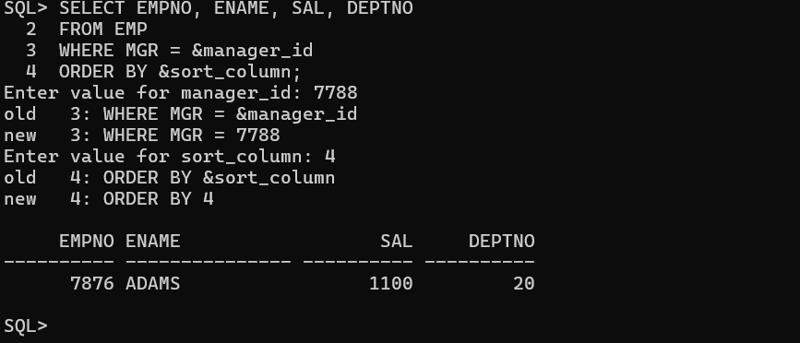

13. Prompt for MGR, generate empno, ename, salary, department for that manager's employees, sortable on a selected column.
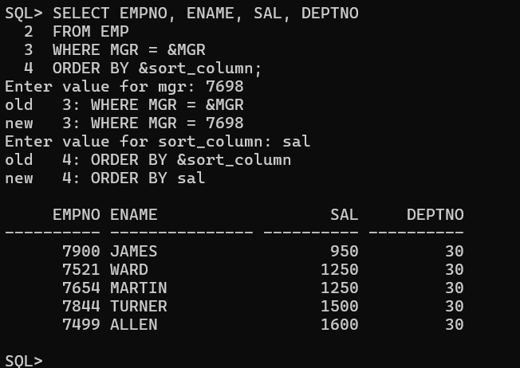
14. Employee last names where the third letter of the name is A.
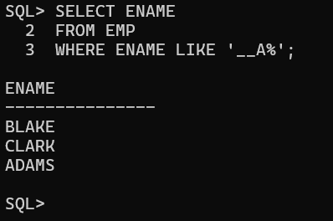
15. Last name of employees who have both an A and an S in their ename.
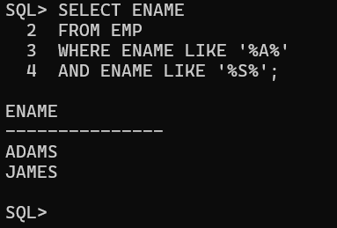
16. Ename, Job, Sal for employees whose job is CLERK and salary is 800, 950, or 1300.
